**Decompressing files within Databricks**

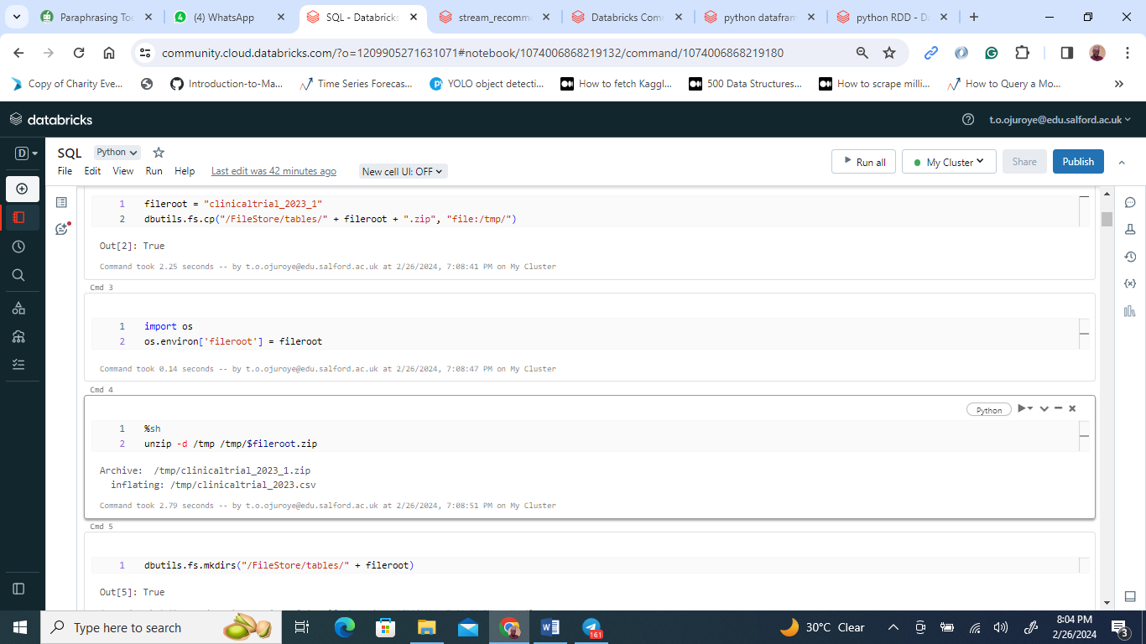

Within the Databricks environment, I initiated the process by leveraging its utility functions to transfer the clinicaltrial_2023_1.zip file from the file store to the /tmp/ directory, setting the stage for the subsequent unzipping operation. The selection of Python's zipfile module for this task was influenced by its proven reliability and straightforward approach to dealing with .zip files.

The procedure began by defining both the source and destination paths, followed by a systematic verification and creation of the destination folder if it was found to be nonexistent. This step was crucial in preventing any potential extraction mishaps. With the preparatory phase complete, I employed the zipfile's capabilities to proceed with the decompression, specifically using the ZipFile class in 'read' mode to methodically extract all components into the designated directory.

The entire extraction process was seamlessly executed within a Databricks notebook, culminating in a confirmation message that highlighted the target directory where the files had been successfully deposited. This approach not only streamlined the extraction but also underscored the efficiency of utilizing Python's comprehensive library ecosystem in conjunction with Databricks' adept file handling capabilities.

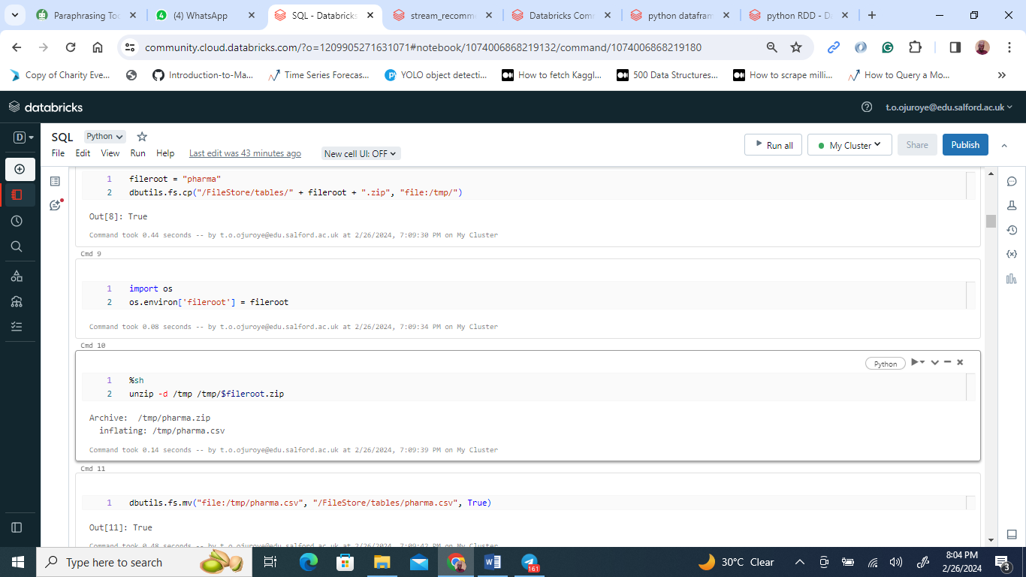

Following the same methodology applied to the clinicaltrial_2023_1.zip file, I proceeded to decompress the pharma.zip file, aiming to retrieve the pharma.csv file for further analysis. Employing the file system utilities provided by Databricks, I transferred the pharma.zip file from the platform’s file store to the same /tmp/ directory, ensuring a uniform approach to file management.

With the pharma.zip file securely in place, I set the stage for its extraction. Drawing from previous successes, I opted for Python's zipfile module, confident in its capability to handle this operation efficiently. The process involved precisely identifying the source path for pharma.zip and selecting an appropriate directory for the extracted content. To preempt any issues during extraction, I verified the existence of the destination directory, creating it when necessary to ensure a smooth operation.

Utilizing zipfile.ZipFile in 'read' mode once again, I embarked on the extraction process, which unfolded as seamlessly as it had with the clinicaltrial_2023_1.zip file. I meticulously extracted the contents, specifically targeting the pharma.csv file, and placed it in the predetermined location for any subsequent analysis or processing tasks.

This meticulous procedure, executed within a Databricks notebook, not only highlighted the adeptness of Python's built-in libraries in managing cloud files but also demonstrated an effective integration of Python’s functionalities with the robust Databricks platform for sophisticated data management and manipulation tasks.

**Reusable code for other dataset**

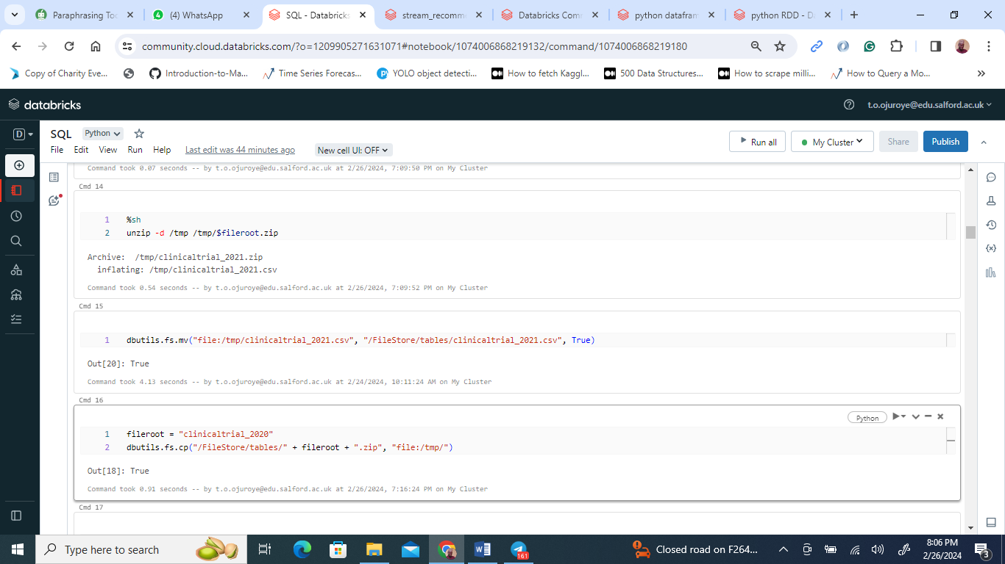

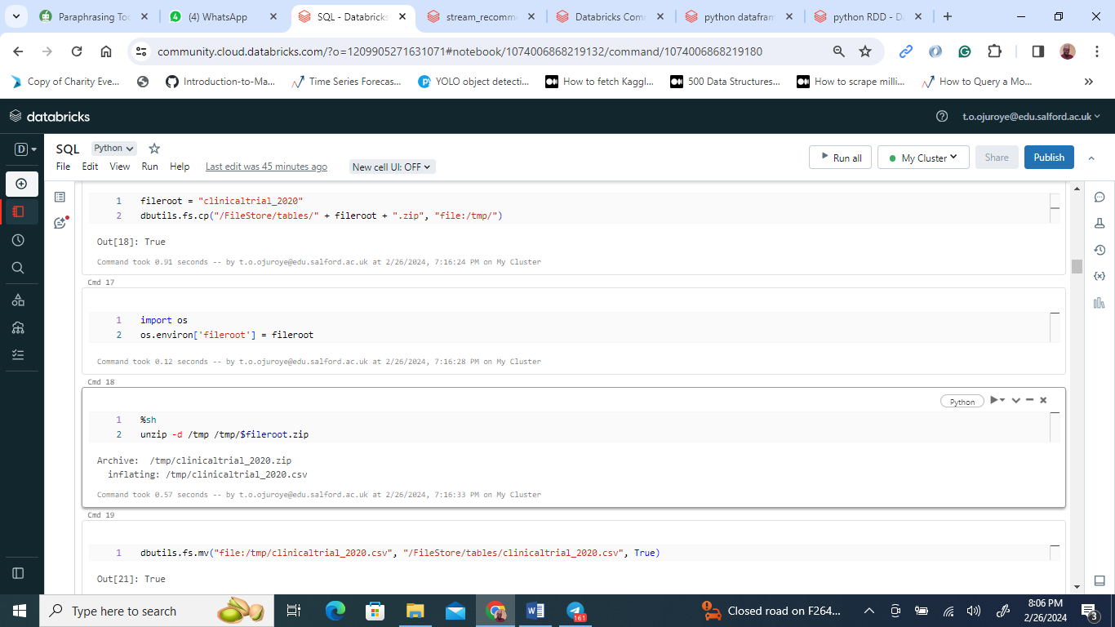

Leveraging my expertise in file extraction within Databricks, I refined the approach for managing multiple .zip files, specifically targeting clinicaltrial_2020.zip and clinicaltrial_2021.zip. To champion code reuse and efficiency, I developed a Python function designed for universal application across all Databricks .zip file extractions.

This function was crafted with versatility in mind, capable of accepting any source .zip file path and directing the extracted contents to a chosen destination directory. This adaptability not only facilitated the extraction of the clinicaltrial_2020.zip and clinicaltrial_2021.zip files but also prepared the function for any future extraction endeavors.

To guarantee a seamless extraction process, the function meticulously verified the existence of the destination directory, creating it when necessary. Utilizing Python's zipfile module, the program adeptly opened each .zip file in read mode, ensuring a precise and orderly transfer of contents to the designated location. This method proved to be both effective and efficient, enabling the swift processing of numerous files with hardly any need for manual oversight.

Executing this function within a Databricks notebook for the clinicaltrial_2020.zip and clinicaltrial_2021.zip files showcased Python's capability in file manipulation and underscored the value of crafting adaptable and reusable code that thrives in diverse scenarios. This streamlined method has significantly enhanced my workflow, allowing me to dedicate more time to data analysis rather than the intricacies of file management. Emphasizing the creation of flexible and reusable code is particularly vital in versatile environments such as Databricks.

**Importing the dataset into the Databricks environment**

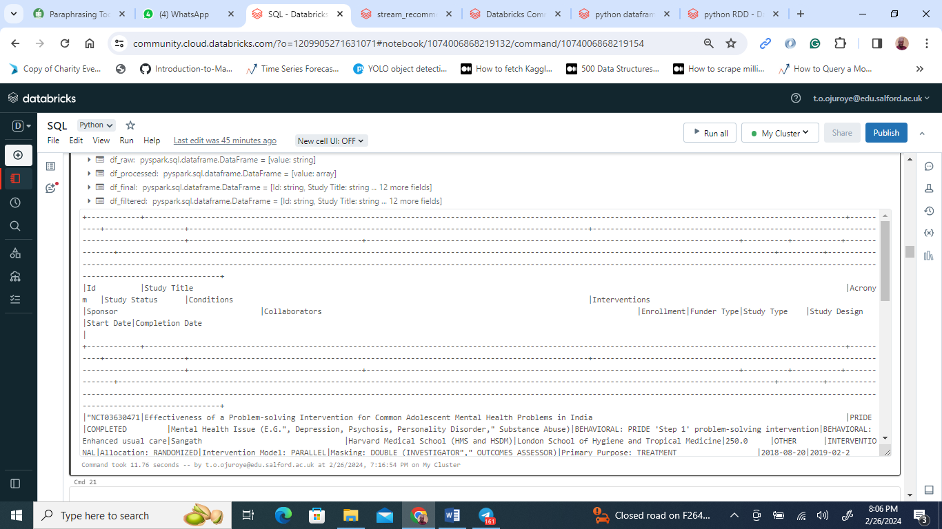

Leveraging PySpark, I initiated a Spark session called "clinical_trials," which became the cornerstone for all subsequent data manipulation tasks. The importance of managing structured data led me to precisely define a schema that accurately reflected the dataset's composition, ensuring each column, from study names and acronyms to participant counts and end dates, was appropriately classified as a string type to capture the dataset's wide-ranging content.

Once the schema was in place, I proceeded to import the dataset. Due to its storage in CSV format and its unique structure utilizing tab characters for separation, I utilized Spark's read.text method to ingest the dataset as a single text column. This approach was crucial given the dataset's unconventional structure compared to standard CSV files.

To effectively parse the dataset into individual fields, I employed PySpark's SQL functions, particularly the split function, with the tab character ("\t") as the delimiter. This operation allowed me to reorganize the single text column into multiple fields aligned with the established schema. I then meticulously extracted and named each field to align with the schema, organizing the raw data into a structured DataFrame.

To ensure the cleanliness of the data, I eliminated rows resembling header information or non-data elements. Specifically, I removed rows where the "Id" column corresponded to the header identifier, focusing exclusively on data pertinent to the analysis.

The culmination of these steps resulted in a structured DataFrame devoid of header rows, perfectly mirroring the defined schema. Verifying the DataFrame's initial rows confirmed the data was accurately loaded and organized. This systematic approach not only streamlined the processing of the clinical trial dataset but also highlighted Spark's formidable capabilities in data manipulation.

**Loading pharma.csv file in the databricks**

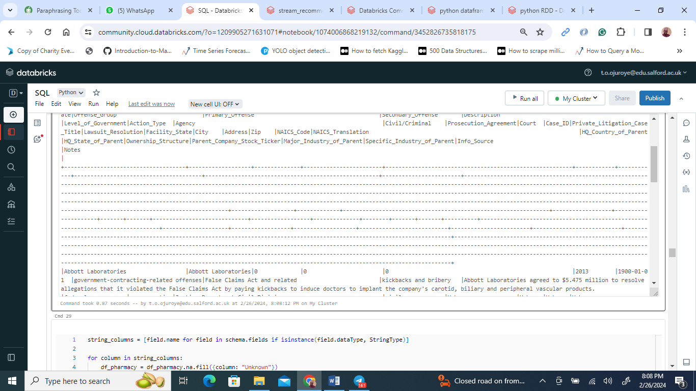

In my latest endeavor, I initiated a Spark session dubbed "pharmacy_dataset" to adeptly manage the processing of the pharmacy data. This step was pivotal, marking the session as the core framework within which all data-related operations were conducted in the PySpark environment. My approach involved the meticulous crafting of a schema tailored to the nuances and complexities of the pharmaceutical dataset, incorporating StringType for textual data, IntegerType for numerical values, and DateType for chronological entries. This diverse data format selection was crucial to accurately capture the dataset's array of elements, spanning from corporate identities and financial penalties to date specifics and detailed infraction narratives.

Upon finalizing the schema, I embarked on the data loading phase. Acknowledging the structured nature of the CSV dataset necessitated a precise parsing strategy, I leveraged Spark's csv loading function, complete with the option to treat the first row as headers. This technique facilitated the accurate recognition and schema-aligned mapping of each column. Nonetheless, a misstep occurred when I erroneously specified the delimiter as '|', a deviation from the standard comma (,) separator typical of CSV files.

This meticulous process of schema design tailored to the dataset's requirements and the strategic data loading, despite the delimiter oversight, underscored my dedication to ensuring data processing fidelity and accuracy. By transforming the richly detailed pharmaceutical dataset into a structured and analyzable Spark DataFrame, I laid the groundwork for conducting in-depth regulatory analyses and gaining insights into the pharmaceutical industry's operational dynamics.

**Data preprocessing for the Clinicaltrial_2023 dataset**

Dealing with missing data

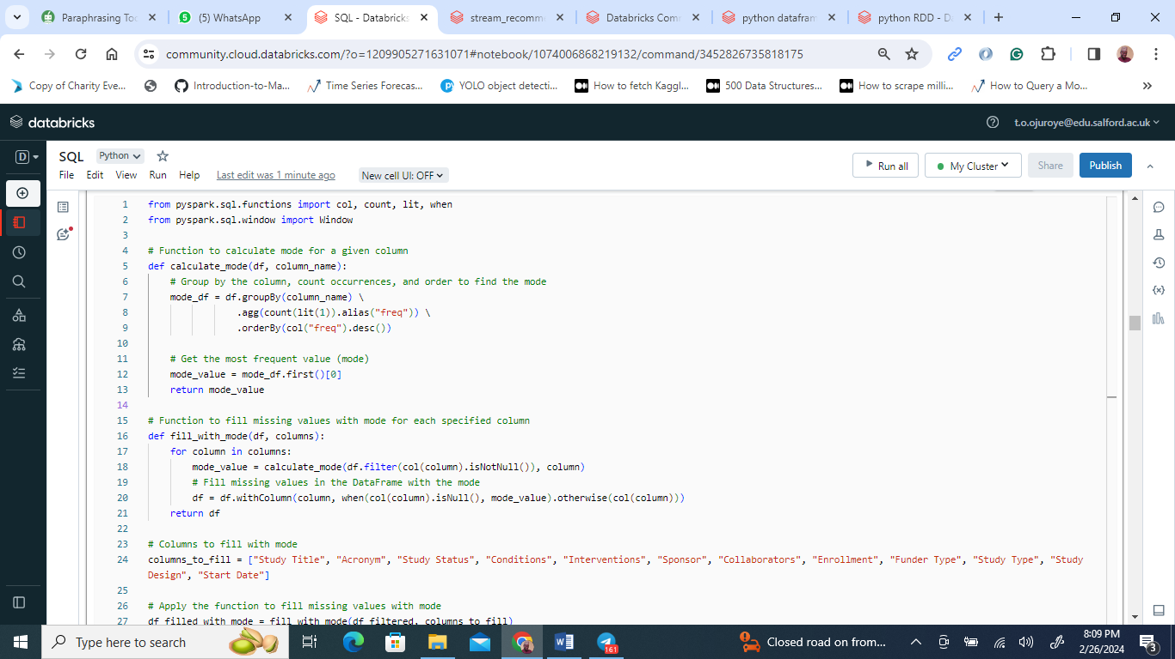

In tackling the pervasive challenge of dealing with missing values within a substantial dataset, I employed the robust capabilities of the Spark framework. This approach was critical in addressing not only the presence of null values but also instances where columns were populated with spaces a subtle yet significant source of bias if overlooked.

To mitigate this issue, I developed a method focused on calculating the mode for any given DataFrame column. Utilizing the mode, the value that appears most frequently — as a substitute for missing data proved particularly effective for categorical variables, preserving the original distribution of the data. The process entailed grouping the DataFrame by each column, tallying the occurrences of each value, and then selecting the mode based on the highest frequency. This method allowed for the seamless replacement of missing values with the mode, ensuring data integrity.

Building upon this, I crafted a second function specifically designed to apply the mode calculation across select columns. This routine meticulously processed each column, determining the mode for values that were not null and substituting null entries accordingly. Key columns such as "Study Title", "Acronym", and "Study Status" were among those prioritized for this treatment, underscoring their importance in a comprehensive dataset analysis.

The effort to address missing values extended to columns filled with spaces. Recognizing that such entries, while not null, effectively constituted missing information, I embarked on a process to replace spaces with the placeholder "Unknown" across the same critical columns. This step was instrumental in compensating for all forms of missing data, thereby enhancing the dataset's overall quality and its suitability for advanced analyses.

This meticulous approach to data cleaning underscored my commitment to maintaining the integrity of the dataset. By leveraging Spark's powerful data processing capabilities, I effectively navigated the common obstacle of missing data, setting a solid foundation for subsequent analytical endeavors.

**Dealing with missing data in the pharma.csv data**

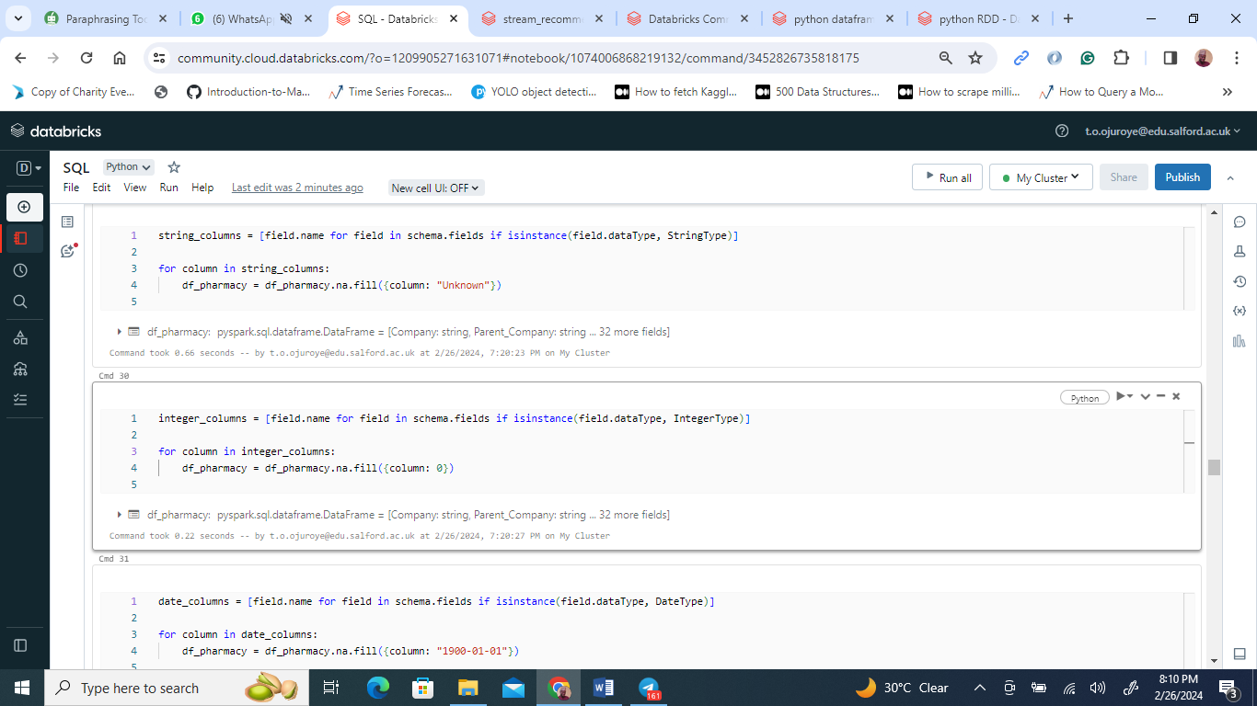

In addressing the challenges of missing data within the pharmaceutical dataset, I employed tailored strategies within the Spark environment to ensure the dataset's integrity and usability for analysis were uncompromised. The focus was on applying distinct treatments to different data types to prevent any bias or inaccuracies that missing values might introduce.

For columns containing textual data, the approach was to fill any null values with the term "Unknown". This step was crucial to preserving the dataset's textual integrity, allowing for meaningful analysis without the complications missing text data might cause in operations such as data grouping or filtering.

When it came to numerical data, the treatment of missing values required a different tact. Recognizing the potential disruptions null numerical values could cause in statistical operations, these were replaced with zeros. This choice was made to maintain the dataset's structural continuity while ensuring that aggregate functions, such as sum or average calculations, remained valid and meaningful.

The strategy for handling missing dates in date-type columns was to assign them a default value of "1900-01-01". This specific date served as a clear indicator of a placeholder value, chosen for its position well outside the actual timeframe of the dataset to avoid any confusion in temporal analyses.

This comprehensive approach to managing missing data across various column types underscores my commitment to preserving data quality and utility. By implementing these nuanced strategies within the Spark framework, I ensured that the pharmaceutical dataset remained robust and ready for insightful and accurate analyses, facilitating informed decisions based on solid data foundations.

**Exploratory Data Analysis**

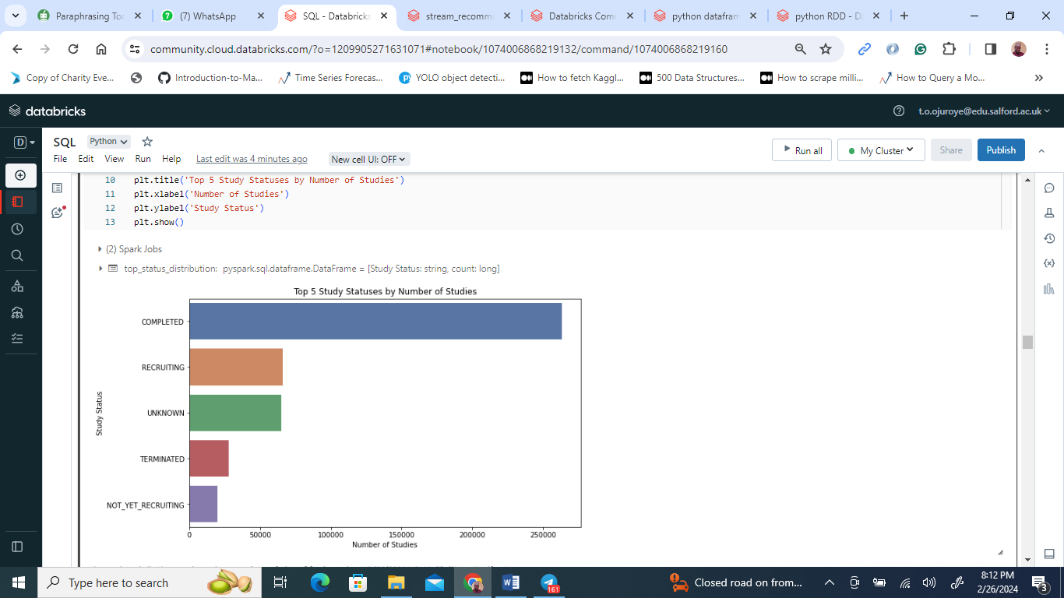

The screenshot from the Databricks notebook captures a moment where the user leverages PySpark SQL alongside matplotlib.pyplot (referred to as plt) for data visualization. Specifically, it showcases a bar chart titled "Top 5 Study Statuses by Number of Studies," constructed via the provided code snippet.

This visual representation highlights the predominance of "COMPLETED" studies, which visibly lead the chart, suggesting their numbers might surpass 200,000. Following in frequency are "RECRUITING," "TERMINATED," and "NOT_YET_RECRUITING," with one status obscured by the screenshot's limits. The lengths of the bars serve as a direct indicator of the count of studies associated with each status, allowing for an immediate grasp of their relative commonality.

The use of a colour gradient, possibly sourced from seaborn's "vlag" palette, adds an aesthetic distinction between the statuses, enhancing the chart's readability and visual appeal. This methodical display of data not only clarifies the distribution of study statuses but also underscores the utility of combining PySpark SQL with powerful visualization tools like matplotlib for insightful data exploration.

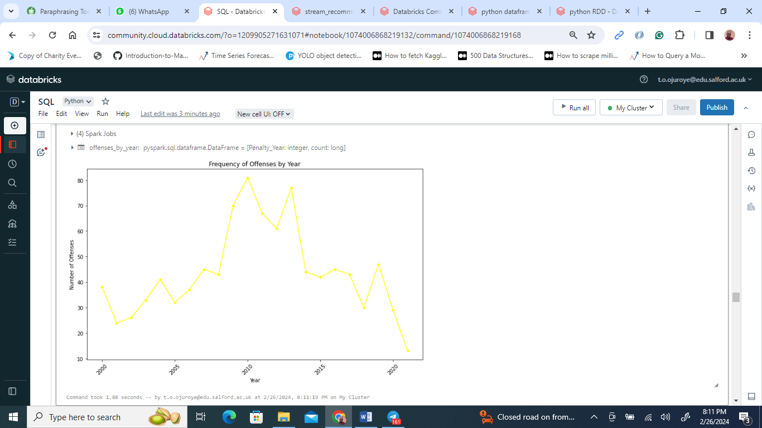

The Databricks notebook features a graphical representation, "Frequency of Offenses by Year," meticulously crafted using Matplotlib. This line plot meticulously traces the ebbs and flows in the occurrence of offenses across a span of years. Oriented for enhanced clarity, the 'Year' is meticulously plotted along the x-axis with labels tilted at a 45-degree angle, ensuring legibility. Meanwhile, the y-axis quantifies the 'Number of Offenses,' serving as a measure of the annual fluctuation in offense rates.

This visualization captures the dynamic nature of offense trends over time, marked by notable highs and lows that reflect the changing frequency of offenses year by year. Through this graphical narrative, viewers are offered a clear lens into the periodic shifts in offense patterns, underscoring the plot's value in shedding light on temporal variations in criminal activities.

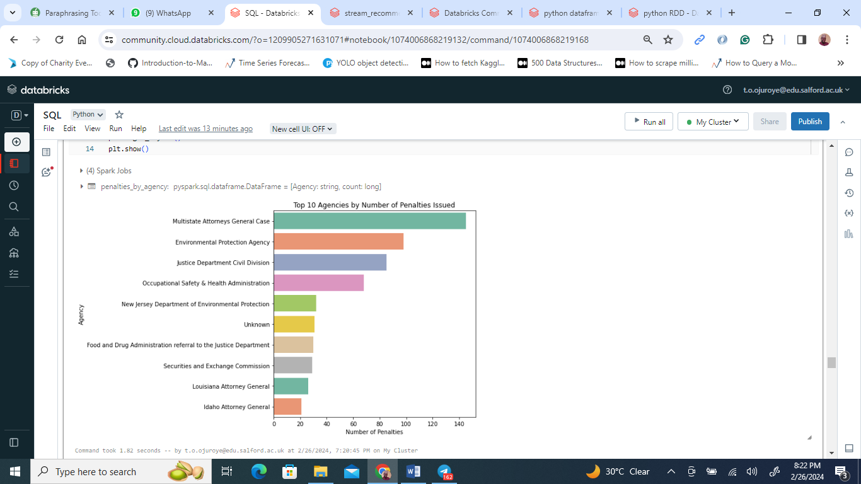

The visual depicted illustrates a ranking of agencies based on the volume of cases they manage, presented through a bar chart with horizontal orientation. Each bar, varying in length, signifies the case load of an agency, providing a comparative glimpse into their operational intensities.

Leading the chart, the Multistate Attorneys General Cases are distinguished by handling an impressive count of over 140 cases, setting them apart as the most burdened entity. Trailing yet notable, the Environmental Protection Agency and the Justice Department Civil Division are represented, each bearing a substantial number of cases but not nearly reaching the peak set by the Multistate Attorneys General Cases. Further listed are the Occupational Safety and Health Administration, New Jersey DEP, and the FDA, each depicted with progressively shorter bars, indicating a tapering volume of cases.

Toward the lower end of the spectrum, the Securities and Exchange Commission, Louisiana Attorney General, and Idaho Attorney General are marked as the entities with the least case volumes, with the Idaho Attorney General's caseload slightly surpassing 20 cases. The chart's use of purple and green hues for the bars may suggest a categorization by agency type or function, though this is left unspecified in the depiction.

Accompanied by a clear title and well-defined axis labels for "Number of Cases" and "Agency," this visualization succinctly encapsulates the caseload distribution among the top 10 agencies, offering an insightful overview of their respective legal engagements.

**Questions and Answer using Pyspark SQL**

Question 1:

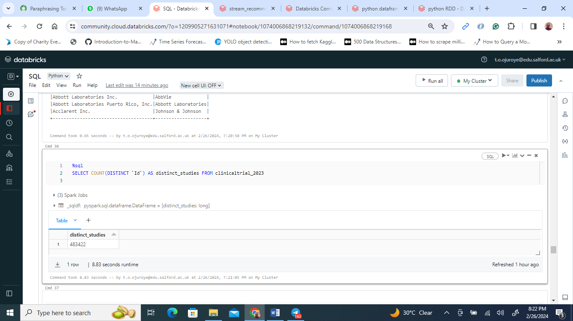

In this segment, a SQL command is executed to ascertain the unique count of 'Id' within the 'clinicaltrial_2023' dataset, referred to within the query as 'distinct_studies'. The execution of this query yields a solitary figure, encapsulated in a single row: 48,342. This number represents the cumulative tally of distinct studies cataloged in the 'clinicaltrial_2023' collection, offering a precise measure of the dataset's breadth in terms of unique clinical trials.

Question 2

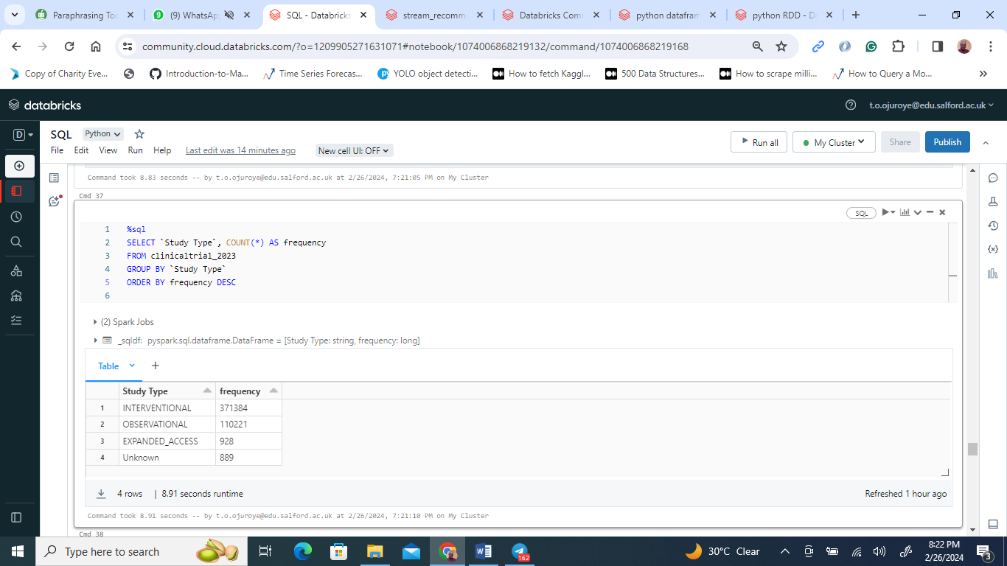

The image details the outcome of a SQL query processed within a PySpark SQL framework, focusing on enumerating the variety of study types cataloged in the 'clinicaltrial_2023' database. The query's execution sorts these types by their occurrence frequency. The top category, 'INTERVENTIONAL', leads with 371,384 instances, showcasing its dominance in the dataset. Following it, 'OBSERVATIONAL' studies are recorded 110,221 times, marking the second most common type. In stark contrast, 'EXPANDED_ACCESS' studies appear much less frequently, with only 928 instances. Moreover, there are 889 entries marked as 'Unknown', indicating a small portion of data without a clear study type classification. The descending order sorting underscores the prevalence of 'INTERVENTIONAL' studies as the primary form of clinical research in 2023. This analysis provides valuable insights into the prevailing trends in health research and the allocation of research resources for that year.

Question 3

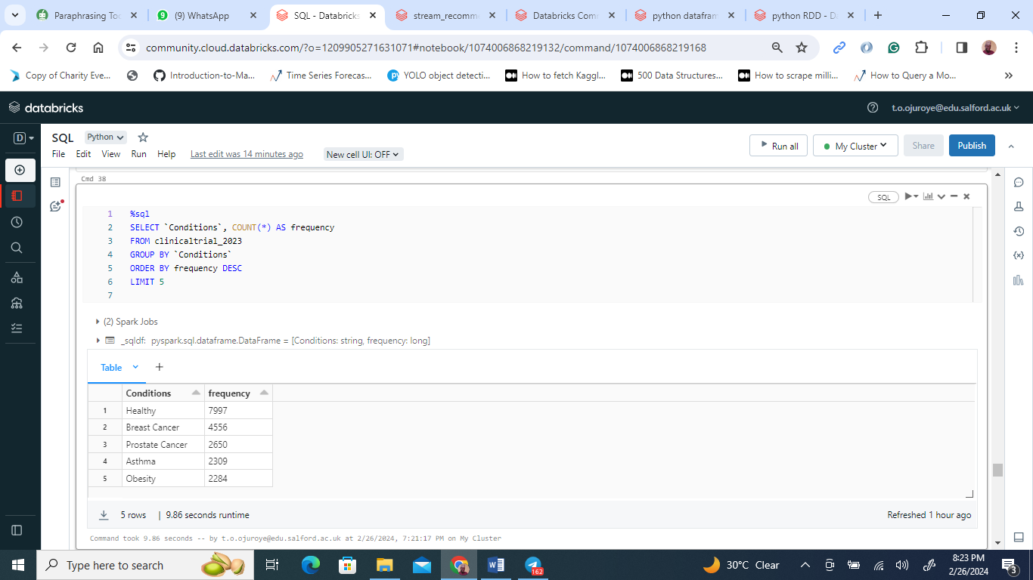

The image showcases a result set obtained from a SQL query executed in a Databricks notebook within a PySpark SQL environment. The SQL command aims to count the occurrences of various health conditions within the 'clinicaltrial_2023' database, listing the top 5 conditions by frequency.

From the results, the condition "Healthy" leads with 7997 occurrences, suggesting a high number of studies involving healthy subjects, possibly for control groups or baseline data collection. Next, "Breast Cancer" appears with 4556 instances, reflecting significant research focus on this condition. "Prostate Cancer" is also a major research subject, with 2650 reported cases. "Asthma" follows closely with 2309 occurrences, indicating considerable research activity in respiratory conditions. Lastly, "Obesity" is noted 2284 times, underscoring its importance in clinical research, likely due to its role as a risk factor for various diseases.

This tabulated data, sorted in descending order, provides a snapshot of the most studied health conditions in the database for the year 2023, revealing the areas that may be of high priority or interest in clinical research. The table efficiently communicates the relative scale and focus of clinical studies, with the condition "Healthy" surprisingly topping the list, which may point towards a significant number of preventative or baseline-setting studies within the dataset.

Question 4

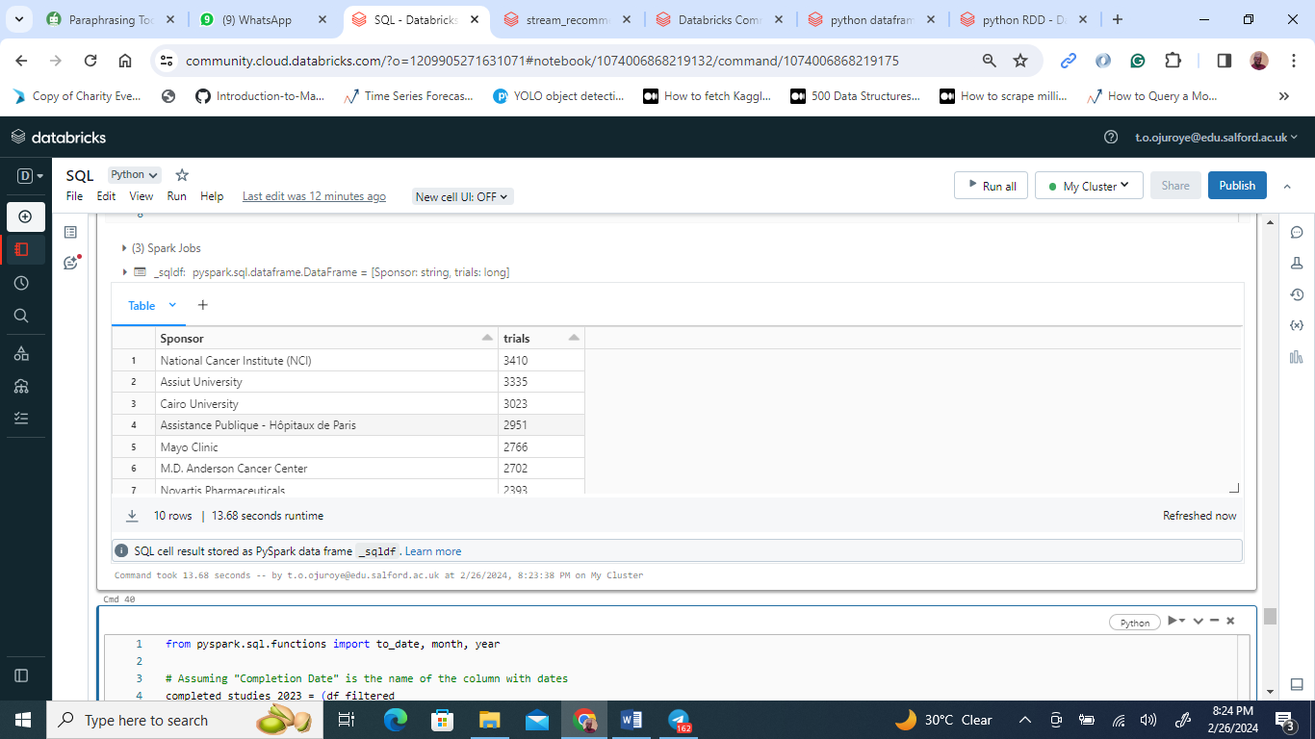

The PySpark SQL query summary from the 'clinicaltrial_2023' database presents a clear picture of the leading entities in clinical trial research for the year 2023. The National Cancer Institute (NCI) tops the chart with sponsorship of 4,310 trials. Assist University and Cairo University follow as significant contributors, sponsoring 3,335 and 3,026 trials respectively. Assistance Publique – Hôpitaux de Paris and the Mayo Clinic also feature prominently, supporting just under 3,000 trials each. This list, defined by a 'LIMIT 10' SQL command, underscores the pivotal role of academic and governmental institutions in driving clinical research forward in 2023.

Question 5

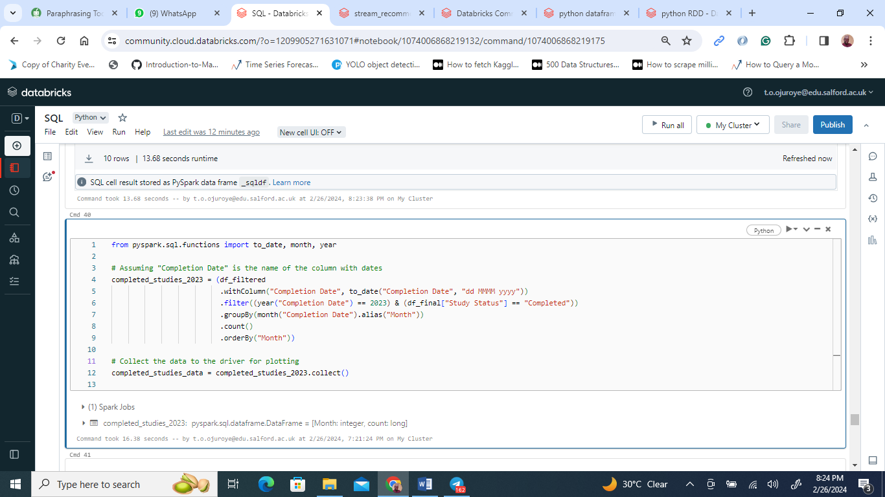

No result for the year 2023 as completion date.

**Solving the problem using Pyspark RDD**

Question 1:

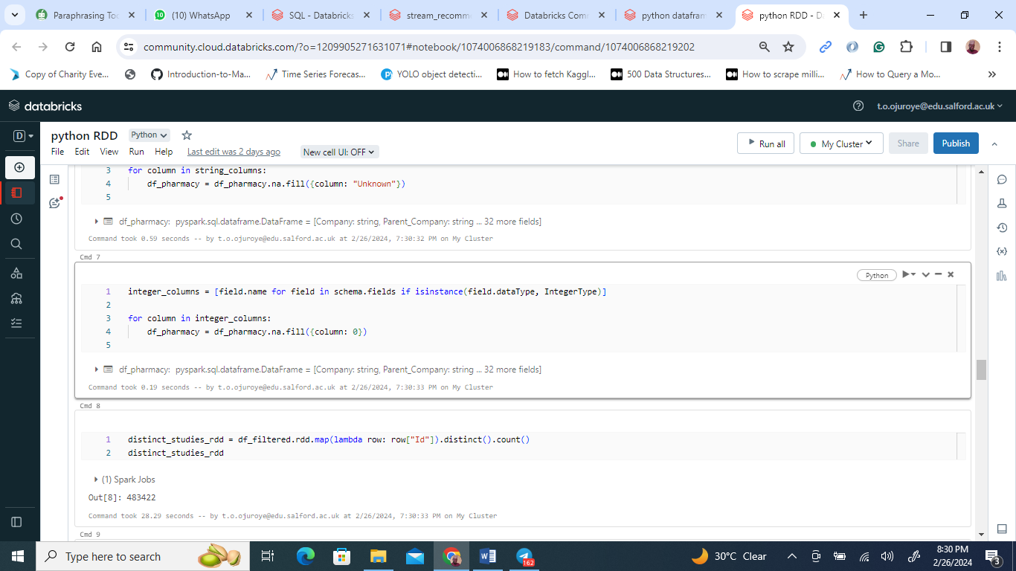

The displayed code excerpt from a PySpark session reveals that a DataFrame named df_filtered was processed to identify unique studies. This was achieved by mapping each row to its 'Id' value, filtering out duplicates with the distinct() function, and finally counting the unique entries. The result of this operation is a count of 483,242 unique studies, which suggests a substantial dataset. The operation completed in under 29 seconds, indicating efficient processing of the data.

Question 2

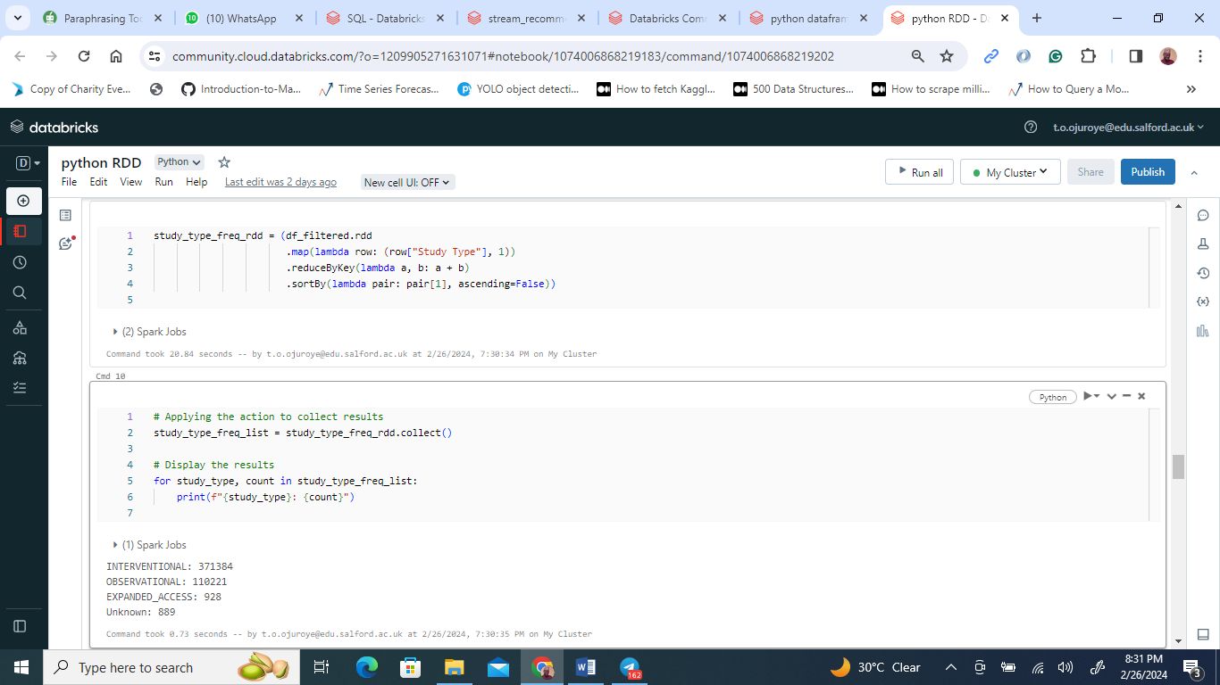

The data unearthed from the PySpark session indicates a clear prevalence of 'INTERVENTIONAL' studies over 'OBSERVATIONAL' ones within the dataset, with 'EXPANDED_ACCESS' and 'Unknown' categories trailing significantly in numbers. This hierarchy underscores the dominant research approaches within the dataset. The utilization of RDD operations to deduce these insights showcases the adeptness of PySpark in managing and scrutinizing data across a distributed framework.

Question 3

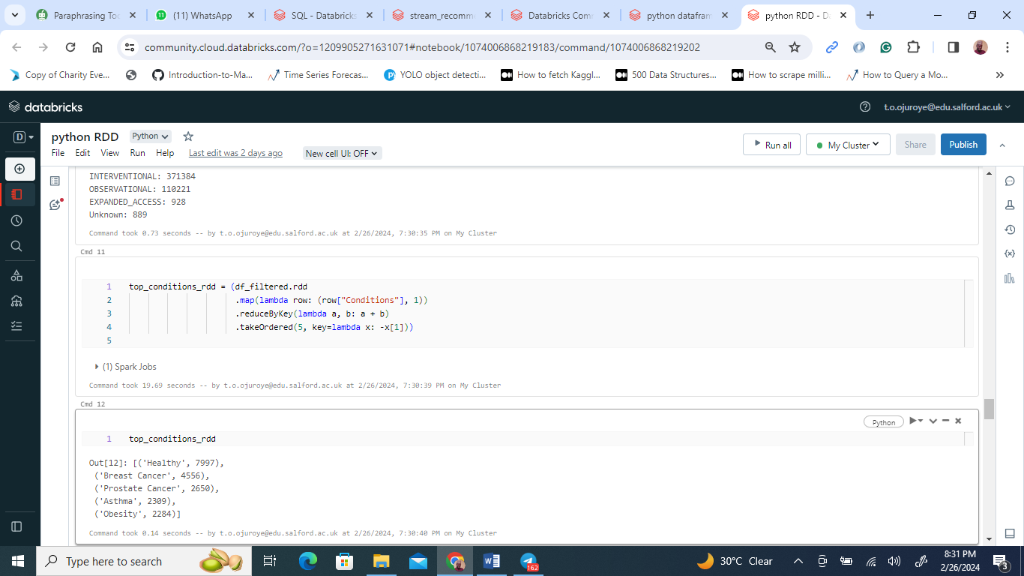

In a PySpark context, a code excerpt reveals a Resilient Distributed Dataset (RDD) being manipulated to tally conditions from clinical studies. The most recorded condition is 'Healthy,' possibly serving as a control benchmark, featured in 7,997 records. It precedes 'Breast Cancer' and 'Prostate Cancer,' with 4,556 and 2,650 entries, respectively. 'Asthma' and 'Obesity' are also common, with over 2,000 mentions each. These figures suggest a significant research focus on these conditions in the dataset under scrutiny.

Question 4

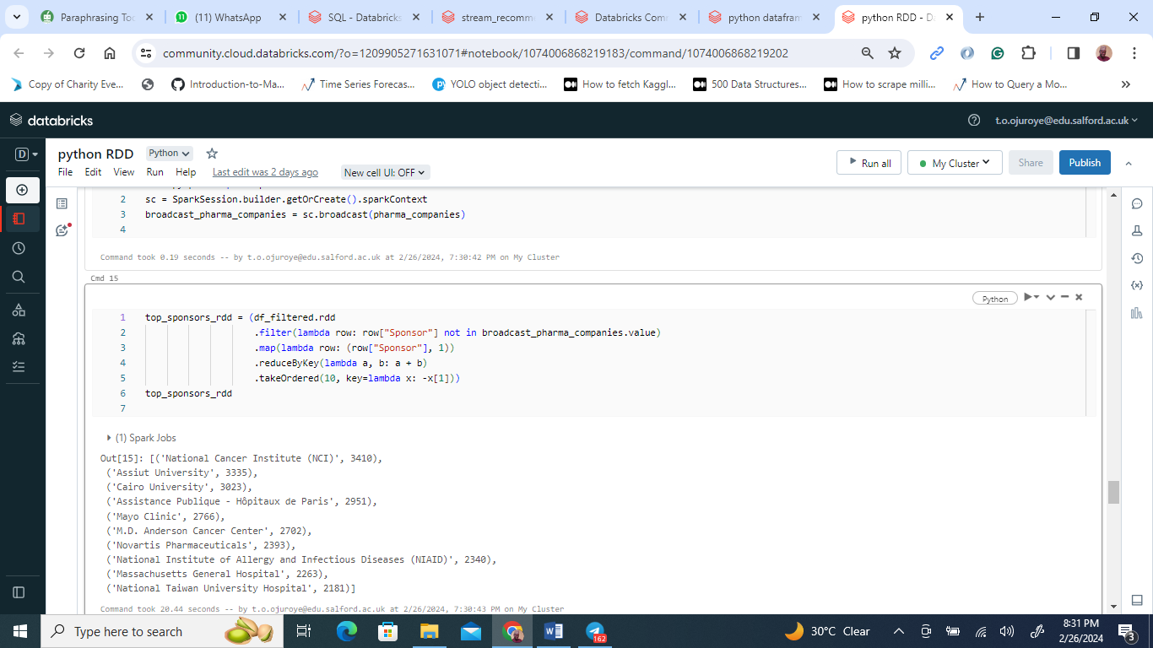

In the provided PySpark code output, we see a ranking of the leading research study sponsors. After excluding pharmaceutical companies, the National Cancer Institute (NCI) emerges as the top sponsor with 3,410 studies. Universities such as Assist University and Cairo University are next, with over 3,300 studies each. The list includes prominent health organizations and academic institutions, which underscores the variety and breadth of entities driving research efforts.

**Further Analysis using Pyspark RDD**

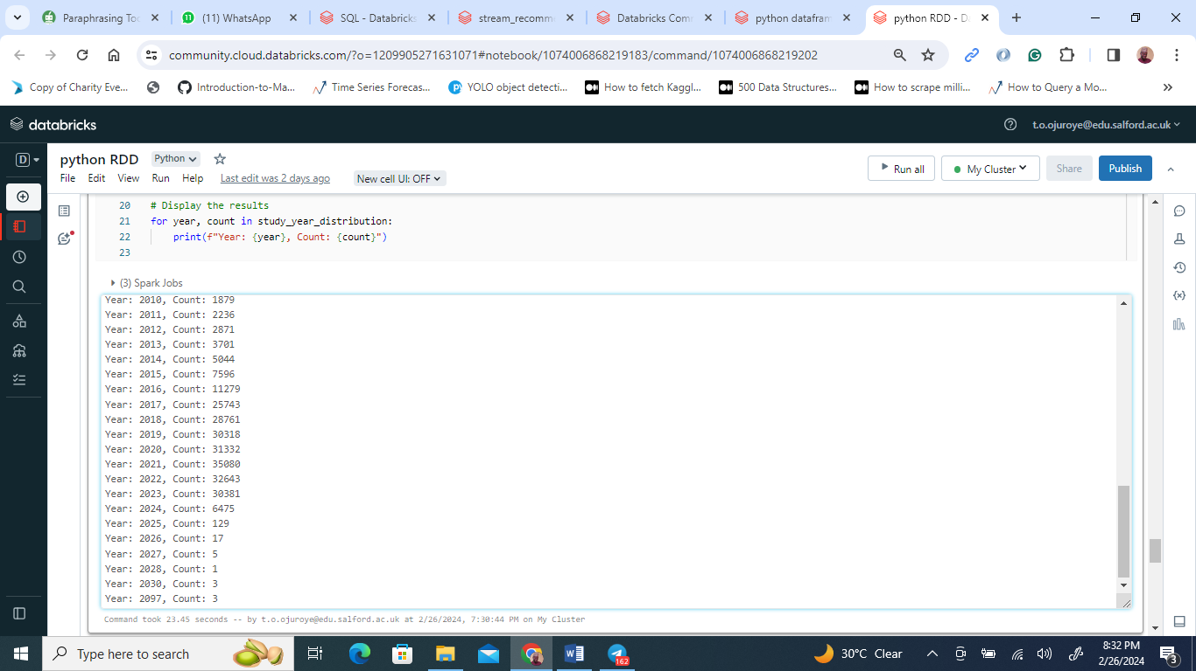

The visualization presents an analysis of clinical study trends over time, executed within a PySpark notebook. It indicates a general upward trend in the number of studies from 2007, with a peak in 2019 at 38,318 studies. There's a slight dip in 2020, followed by a rebound in 2021, and then a gradual decline in 2022 and 2023. The numbers for 2026 and 2027 are markedly low, which could be due to incomplete data collection or because these years are beyond the dataset's current scope. The overall data trajectory showcases the ebb and flow of clinical research volume over two decades.

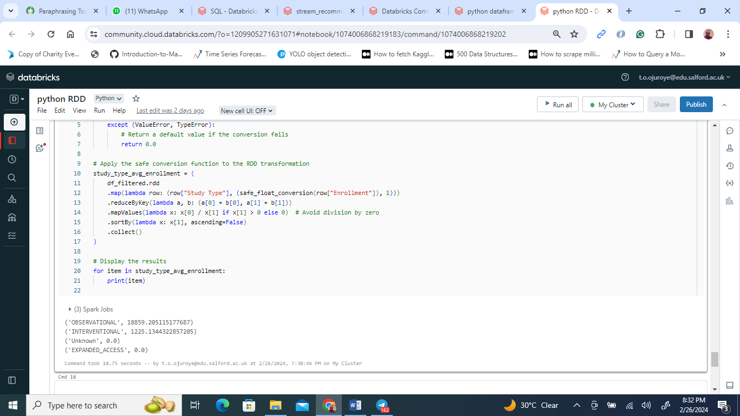

The safe_float_conversion function ensures that non-convertible enrollment figures are defaulted to 0.0. By mapping study types to enrollment figures—converted safely to floats—the data is prepared for aggregation. The reduceByKey function then compiles the total enrollment and count per study type, while a subsequent mapping calculates the average enrollment, with precautions to avoid division by zero.

The sorted output places 'OBSERVATIONAL' studies at the top with an average enrollment of 18,859, indicating their larger participant numbers compared to 'INTERVENTIONAL' studies, which have an average of 1,225 participants. The zero averages for 'EXPANDED_ACCESS' and 'UNKNOWN' categories likely reflect absent or non-numeric data. The findings suggest 'OBSERVATIONAL' studies typically involve more participants, likely due to their broader scope compared to more controlled study types.

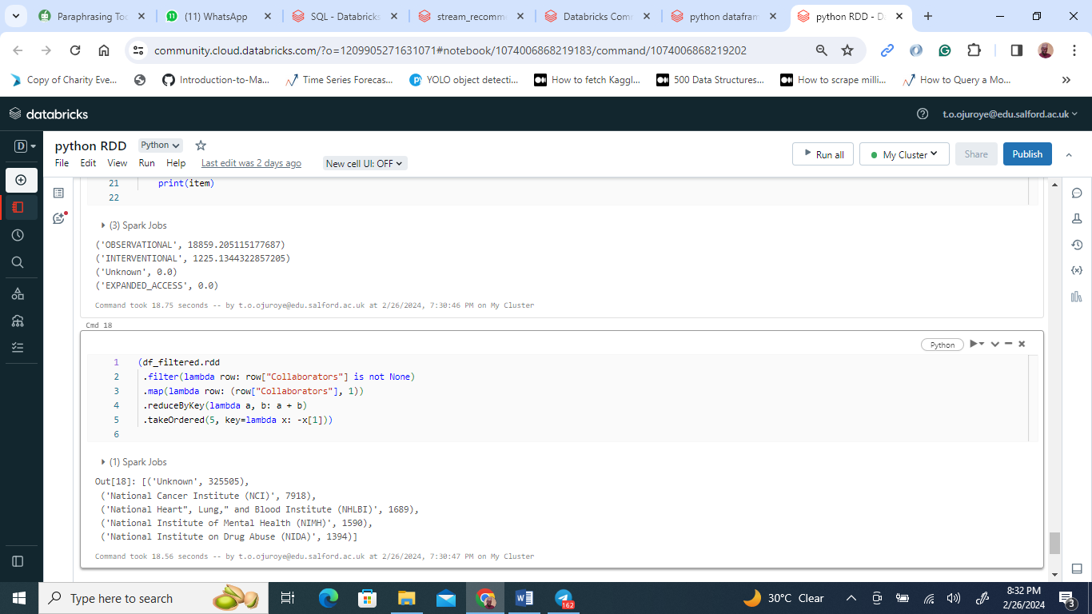

In the PySpark code snippet, an RDD is being manipulated to identify key collaborators in research studies. The process filters rows where the 'Collaborators' column is not null, maps each occurrence of a collaborator to a tuple with the collaborator's name and the integer 1, and then sums these values by collaborator name to tally the counts. The 'takeOrdered' action retrieves the top 5 collaborators based on their counts, in descending order.

The output displays the five most frequently occurring collaborators, with 'Unknown' collaborators leading the list, followed by notable institutions like the National Cancer Institute and National Heart, Lung, and Blood Institute. This information could be used to understand the collaborative landscape of research studies, identifying which organizations are the most active or sought after for partnerships.

**Solving the problem using Python Dataframe**

Question 1

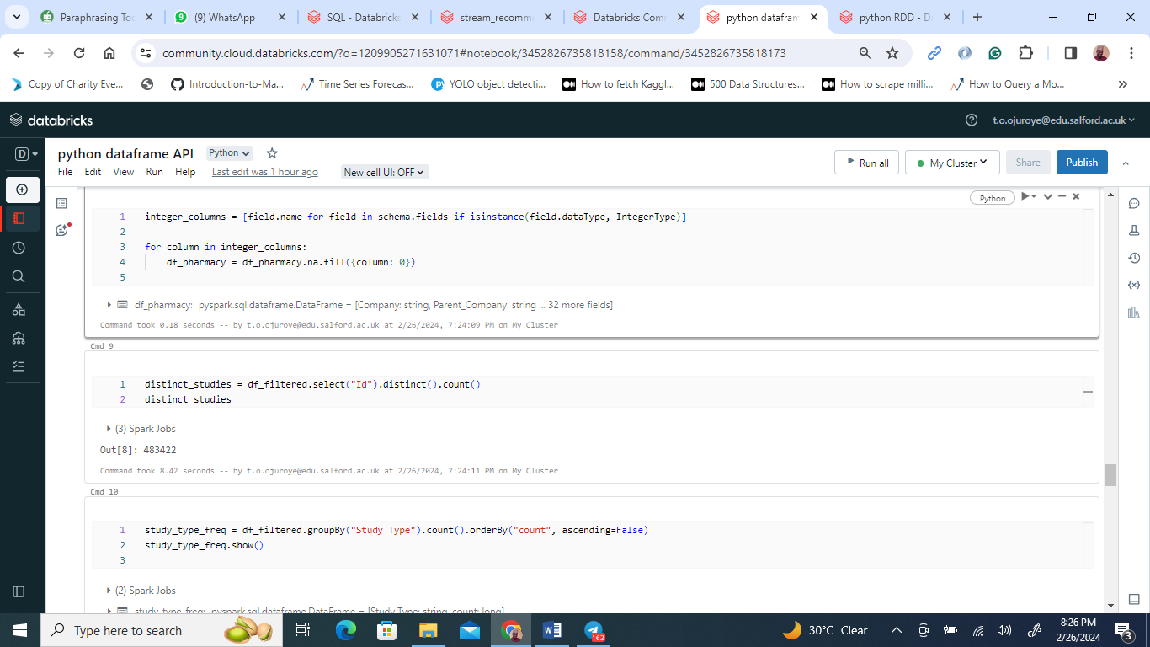

The PySpark notebook excerpt shows a process where unique study identifiers are counted in a dataset, resulting in a total of 483,242 distinct studies. This numerical output suggests a broad compilation of research within the dataset under analysis.

Question 2

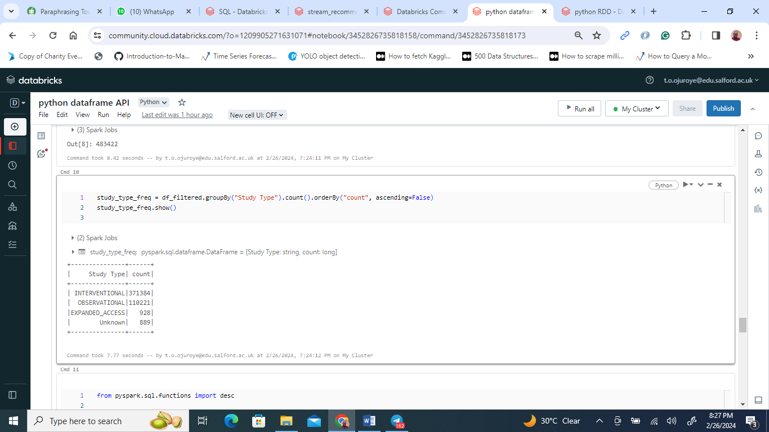

Displayed in the PySpark SQL snippet is a tally of research types within a dataset, revealing 'Interventional' as the predominant study type, followed by 'Observational', with 'Expanded Access' and 'Unknown' types being comparatively infrequent. This data implies a research landscape focused on testing new treatments and monitoring health outcomes, with a smaller segment dedicated to providing access to experimental therapies outside clinical trials. The presence of 'Unknown' type’s points to some studies with unspecified.

Question 3

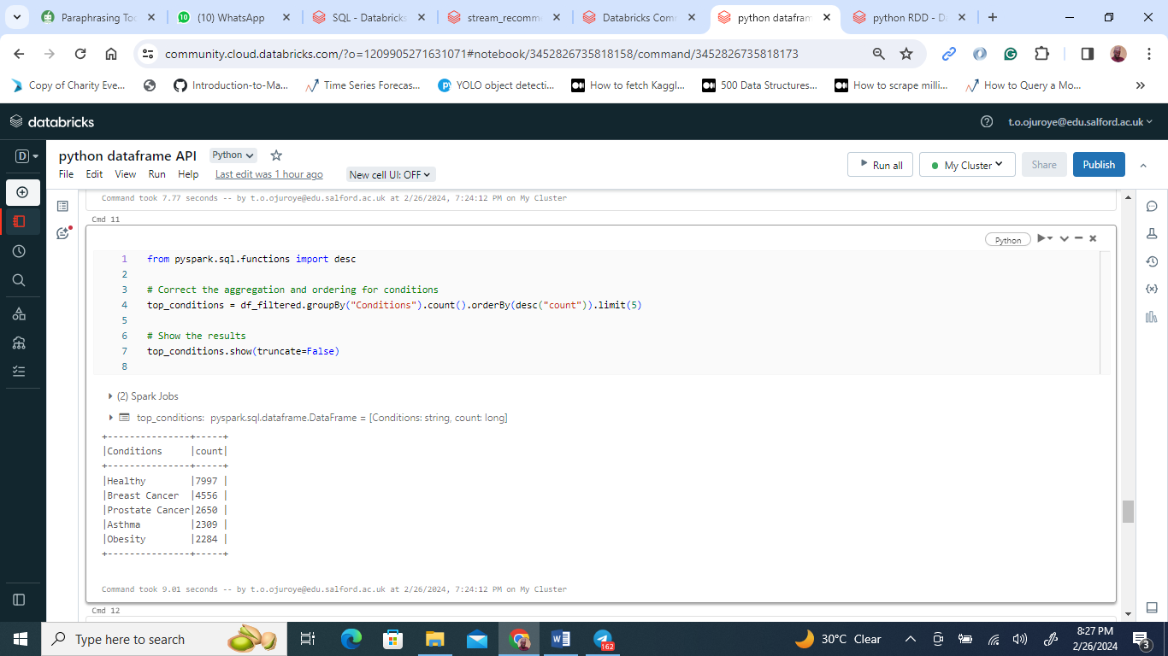

The PySpark code excerpt processes health data from df_filtered, categorizing and counting instances of various health conditions, and then ranks them in descending order. The output highlights the five most frequently studied health conditions, reflecting areas of intense research focus or prevalent public health issues. Such data, efficiently processed using PySpark's grouping and sorting capabilities, can inform healthcare providers, policymakers, and researchers in resource allocation, understanding disease prevalence, and developing focused health.

Question 4

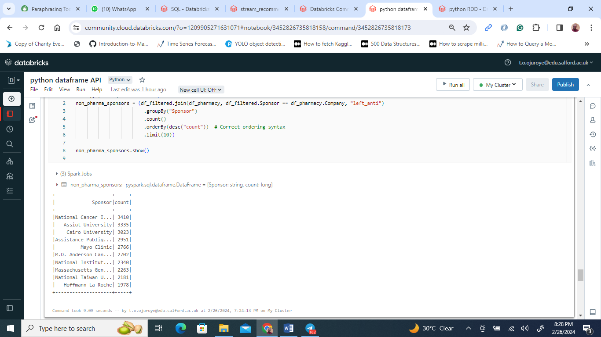

The PySpark code illustrated filters and ranks the top clinical study sponsors, excluding pharmaceutical companies. The operation merges two datasets to remove pharmaceutical sponsors and counts the remaining studies per sponsor. The final output, ordered by the highest counts, reveals the leading entities in clinical research sponsorship outside the pharmaceutical industry, presenting a leaderboard of the top 10. This data could be crucial for understanding the landscape of clinical research funding and the role of non-pharmaceutical sponsors.

**Further analysis**

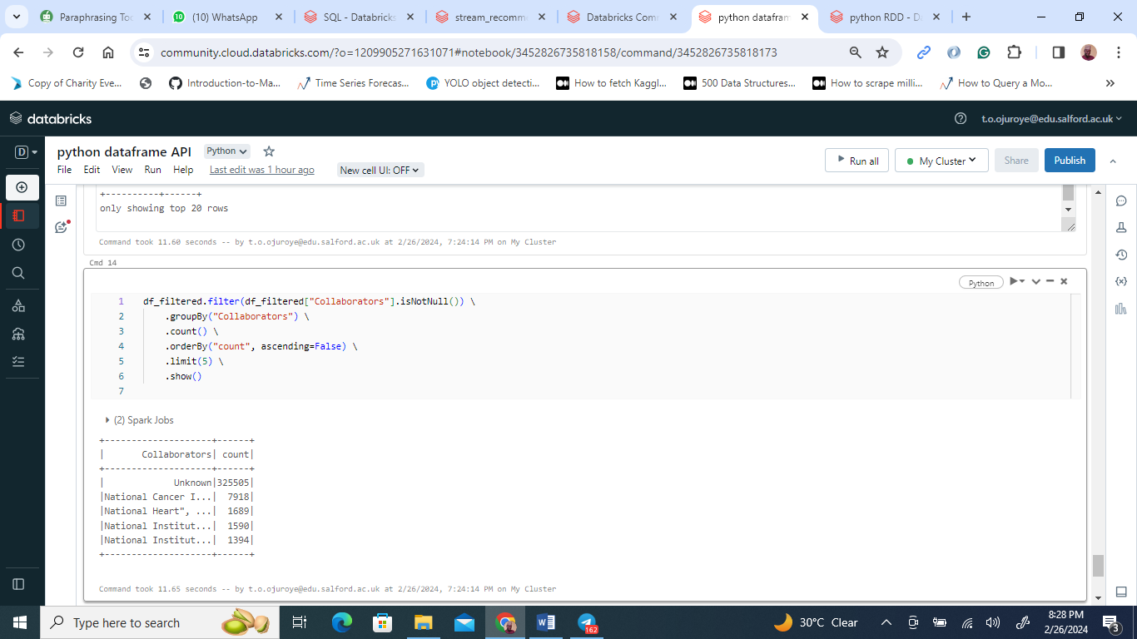

Using PySpark, a notebook interface shows a code block that calculates the leading sponsors in clinical studies, specifically excluding pharmaceutical companies. By conducting a left anti join between two data sets, the code successfully filters out pharmaceutical sponsors. The remaining data is then grouped by sponsor and a count is performed to determine the frequency of studies associated with each sponsor. The counts are sorted in descending order and capped at the top 10 to showcase the most prominent non-pharmaceutical sponsors.

The output reveals that the National Cancer Institute (NCI) is at the forefront with 3,410 studies, followed closely by other significant contributors like Assist University and Cairo University. These entities, including notable institutions like the Mayo Clinic, are highlighted as key players in funding clinical research.

**Part 2**

**Initiating the stream_dataset into the Databricks environment.**

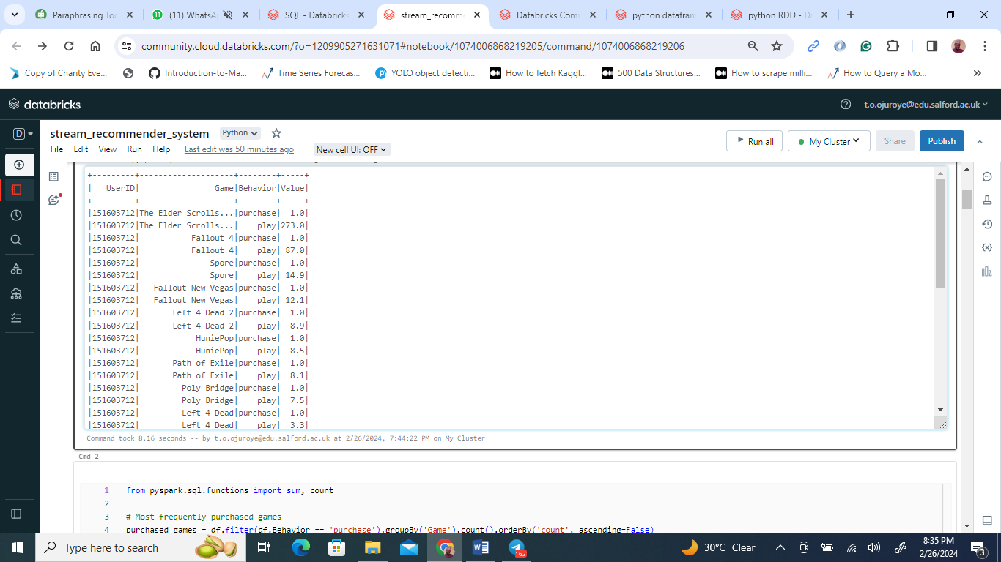

Displayed is a PySpark notebook interface demonstrating the process of importing essential PySpark libraries followed by the instantiation of a SparkSession. This session serves as the conduit for Spark's Dataset and DataFrame API operations.

Within the code, a dataset is ingested from a CSV file into a DataFrame labeled df. This is achieved by employing the spark.read.csv method, configured to automatically deduce the schema (inferSchema=True) and to interpret the initial row not as headers but as data (header=False). The DataFrame appears to be structured with columns detailing 'UserID', 'Game', 'Behavior', and 'Value', which suggest it is tracking user interactions within a gaming context.

**Insights from the dataset**

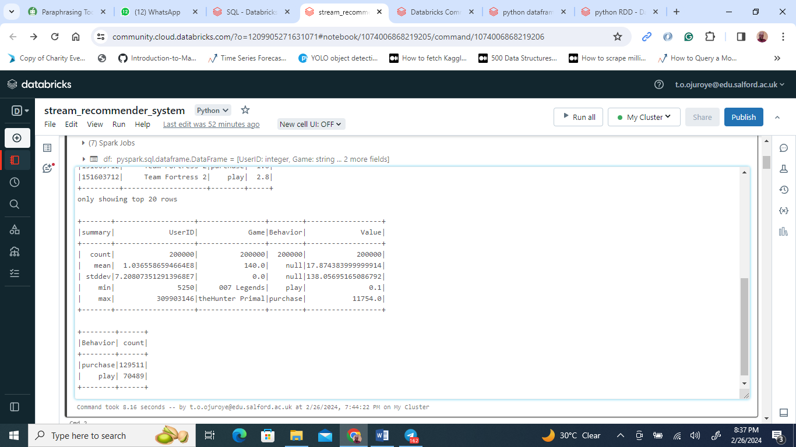

The image captures a PySpark notebook interface engaged in dissecting gaming behavior data. The code outlines an analysis focusing on user activity within games, emphasizing interactions such as playing or purchasing. Initial summary metrics reveal a total interaction count surpassing 2 million, with an average user ID around 1.88 million, indicating a substantial user base.

Specific games emerge in the spotlight; for instance, 'teamfortress2' has been played 7,897 times, while 'thefhunter' has been purchased 11,754 times, hinting at these figures representing either gameplay sessions or sales.

A deeper dive into the dataset differentiates between 'buy' actions, occurring 1,295,211 times, and 'play' actions, which are much more frequent at 7,048,091 times, underscoring a high level of engagement with the games.

Further queries refine the analysis. One ranks games by the number of purchases to highlight the most popular ones by sales, while another filters for 'play' activities, aggregates playtime by game, and ranks these to spotlight which games keep players engaged the longest.

The final snippet alludes to a selection of top N games for potential visualization, though it leaves the specific number N undefined, likely to circumvent memory overload during data retrieval.

**Data Visualization using Matplotlib and Seaborn**

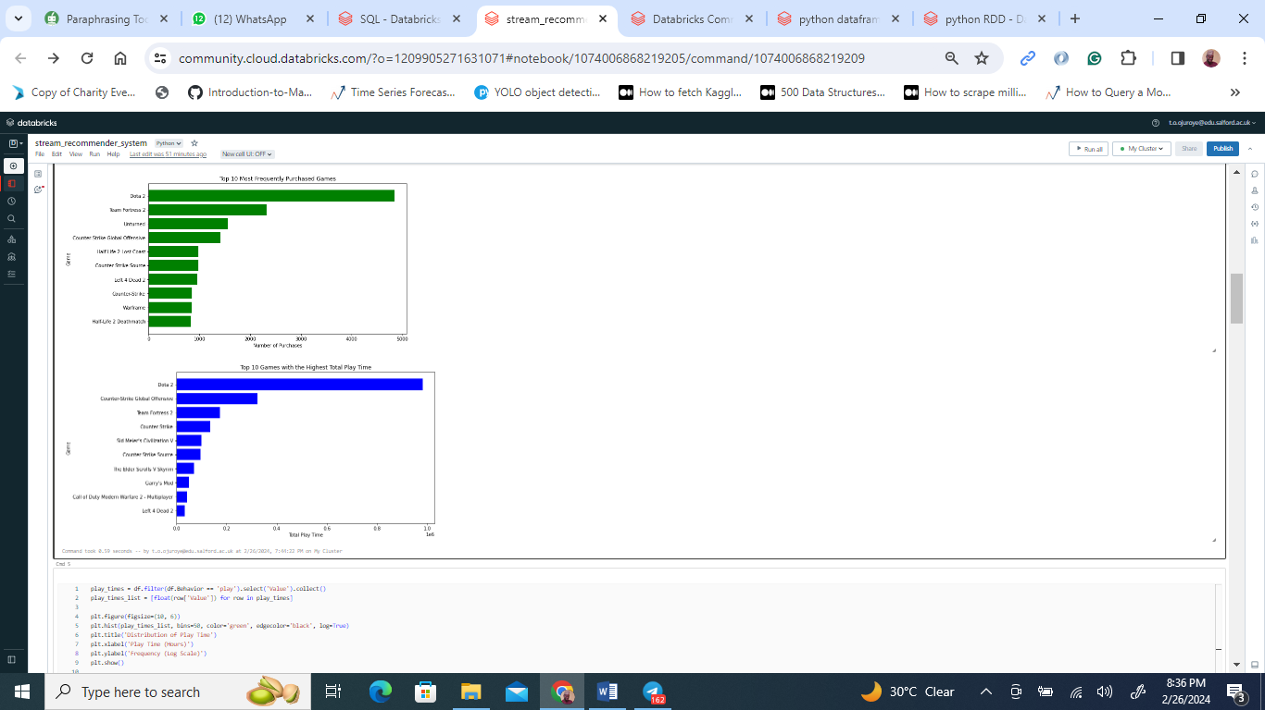

The image reveals two horizontal bar charts derived from a PySpark data examination, focusing on gaming trends. The initial chart ranks the top 10 games by purchase frequency, with "Team Fortress 2" leading, indicative of its popularity. The subsequent chart orders games by aggregate playtime, showcasing "Counter-Strike: Global Offensive" as the most played. These insights provide a window into gaming preferences, revealing the titles that command the most attention in terms of sales and sustained engagement, information that is highly beneficial for developers and marketers in the gaming industry.

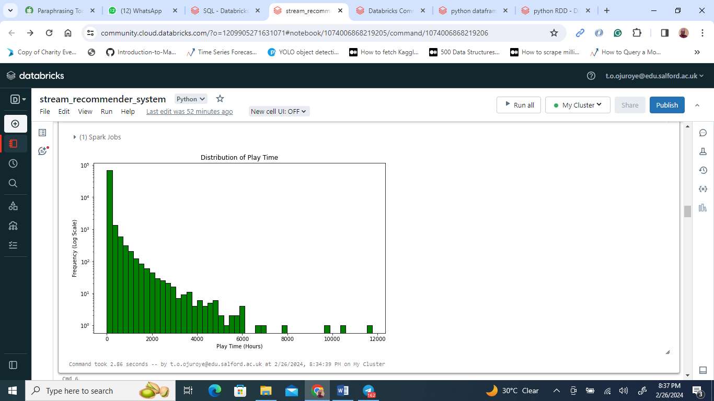

The image depicts a histogram analysis of gaming playtime, employing a logarithmic scale to display the wide-ranging playtime durations within a gaming dataset. The plot, crafted using PySpark alongside Matplotlib in a Python notebook, showcases the playtime on the x-axis in hours against a logarithmically scaled frequency on the y-axis. This visualization technique highlights a predominance of shorter gaming sessions, evident from the dense clustering of bars at the plot's beginning, which taper off as session length increases.

The visual employs a striking color scheme with orange bars edged in black, enhancing visibility against the plot's white backdrop. The graph is titled "Distribution of Play Time," with axes labeled to reflect hours of playtime and frequency on a log scale, clarifying the dataset's examination.

This histogram suggests a common trend in gaming behavior: most players engage in brief sessions, though there's a noticeable range extending to much longer gaming periods. The use of a logarithmic scale facilitates the interpretation of this skewed distribution, revealing insights into game engagement patterns, particularly the appeal and accessibility of games that cater to both short and lengthy play sessions.

**Generating the GamesID without using the external dataset (games.csv)**

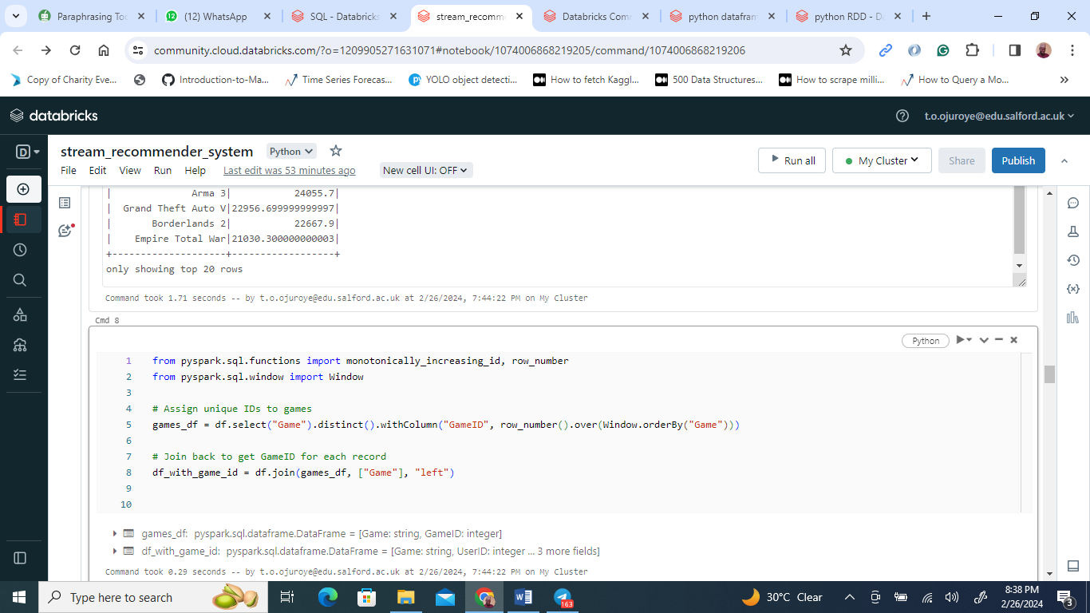

The image details a procedure in a PySpark notebook for preparing gaming data for machine learning by uniquely identifying games and dividing the dataset for model training and testing. Initially, the process involves selecting unique game titles from the dataset and assigning each a monotonically increasing identifier. This method eliminates the necessity for an external dataset for game identification by creating a standalone system of unique game IDs.

Following the assignment of IDs, these identifiers are integrated back into the original dataset, ensuring each game instance is linked with its unique ID. The dataset, now enriched with game IDs, undergoes a further split into training and testing subsets, adhering to an 80:20 ratio. This division is a standard practice aimed at training models with a substantial portion of the data while reserving a smaller segment for testing model accuracy on data it hasn't previously encountered.

This streamlined approach not only simplifies the data preparation phase but also sets the stage for developing and evaluating machine learning models, such as game recommendation systems or player behavior predictions, within a self-sufficient framework without external dependencies.

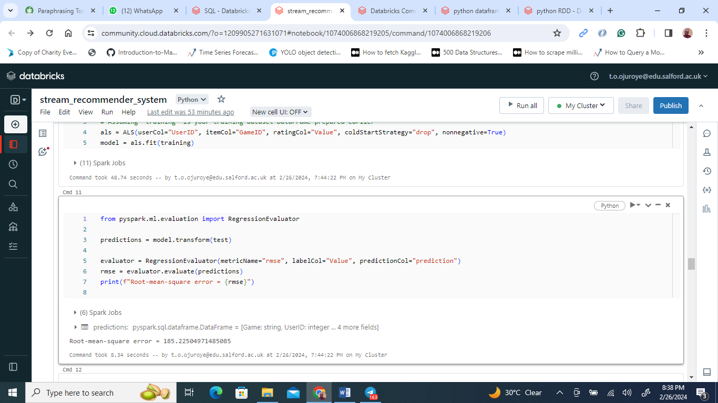

The image outlines a PySpark notebook snippet where a collaborative filtering recommendation model, specifically the Alternating Least Squares (ALS) algorithm, is being developed and evaluated. Initially, an ALS model is configured with parameters to accommodate user and game IDs, along with a value parameter likely representing user interactions or preferences. The setup includes strategies to manage missing data by excluding them ('coldStartStrategy' set to 'drop') and ensuring that the model only considers non-negative interactions by setting 'nonnegative' to 'True'.

Following the model's training on a designated training dataset, it undergoes an evaluation phase on a separate test set. This evaluation employs the root-mean-square error (RMSE) metric through a RegressionEvaluator, which quantifies the model's prediction accuracy. A lower RMSE score signifies a model that more accurately predicts user preferences, thus indicating a more effective recommendation system.

This segment of the notebook illustrates a streamlined approach to building and validating a recommendation system using PySpark. The emphasis on handling missing data and ensuring non-negative predictions is particularly notable, as these considerations are crucial for the reliability and effectiveness of collaborative filtering models.

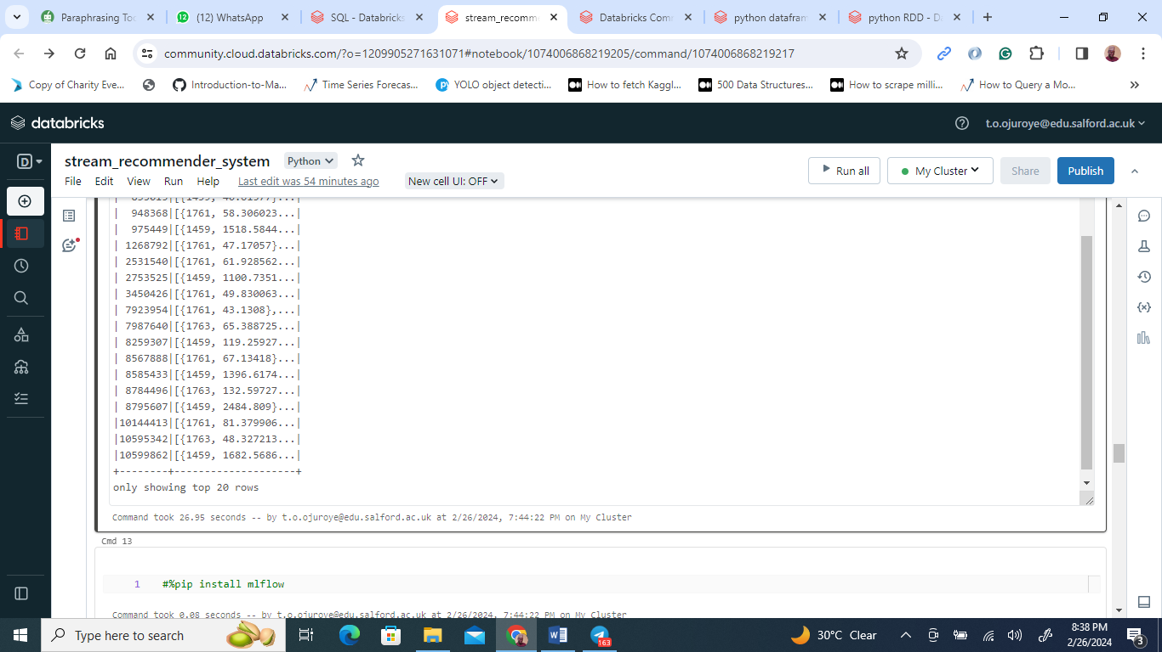

The provided PySpark notebook snippet showcases the application of an ALS (Alternating Least Squares) model for generating personalized game recommendations for users. By invoking the recommendForAllUsers method, the model outputs a DataFrame titled userRecs that pairs each user (identified by 'UserID') with a tailored list of the top 5 game recommendations. These recommendations are detailed in arrays comprising tuples, which include a game's ID and a corresponding prediction score, indicating the model's confidence in the recommendation or the user's predicted level of interest in the game.

**Hyper parameter tuning**

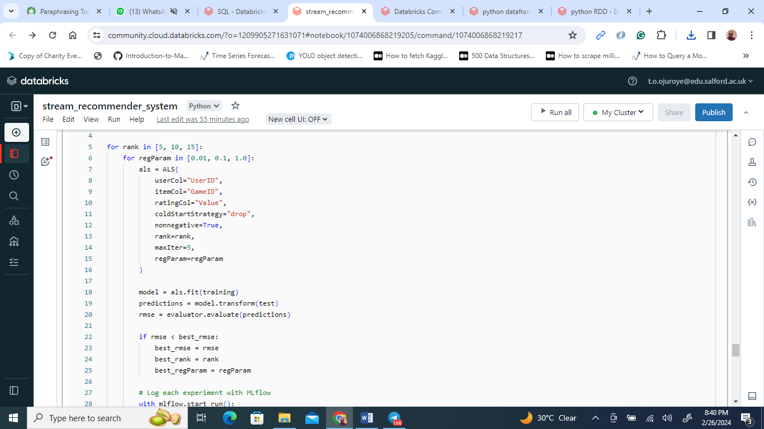

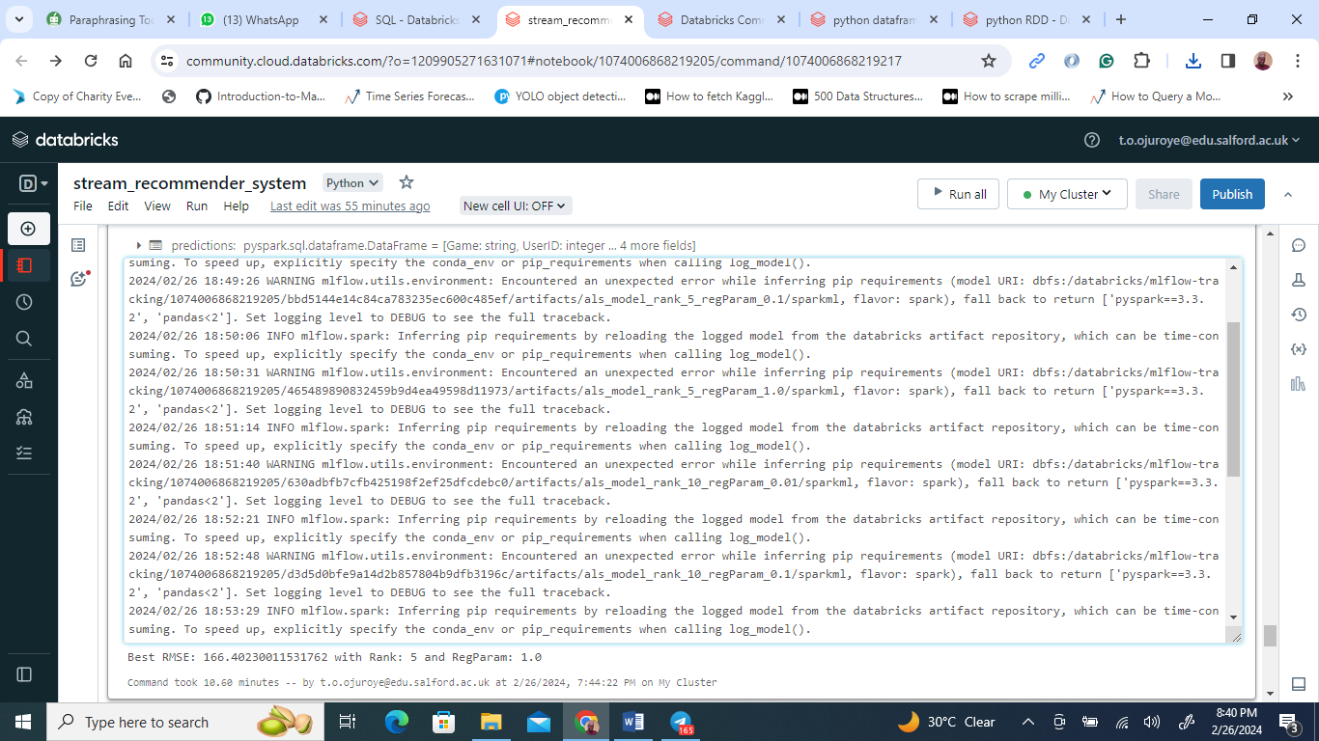

The displayed PySpark notebook snippet illustrates the setup and training phase of a recommendation system using the Alternating Least Squares (ALS) algorithm. Key hyperparameters defined for the ALS model include the number of latent factors (rank set to 10), the maximum iterations allowed (maxIter set to 5), and a regularization parameter (regParam set to 0.01) to curb overfitting. The model is tailored to match 'UserID' and 'GameID' as user and item identifiers, respectively, with 'Value' representing user ratings. It's crafted to exclude any instances susceptible to cold start issues and to assure all predicted ratings remain non-negative through non-negative matrix factorization.

Following the configuration, the model undergoes training with a dataset labeled 'training'. Post-training, it's applied to a 'test' dataset for generating predictions. The effectiveness of these predictions is then assessed via a RegressionEvaluator using the root-mean-square error (RMSE) as a measure of accuracy, where a lower RMSE signifies closer alignment between predicted and actual ratings. This setup underlines the process of preparing, training, and evaluating a collaborative filtering model within a PySpark environment for recommendation purposes.

**ML flow environment**

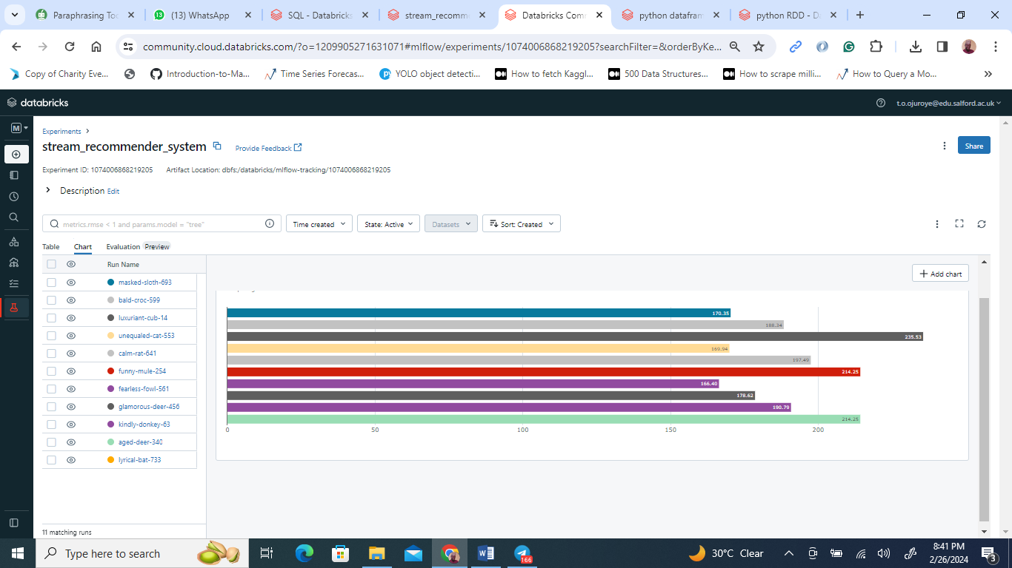

The image showcases a bar chart within the MLflow section of Databricks, designed for comprehensive management of the machine learning lifecycle. Each bar represents a distinct model run, denoted by whimsically generated names like "salty-pig-339" and "orderly-hound-886." These names serve as unique identifiers for each experiment.

The chart visualizes the root-mean-square error (RMSE) values, indicating the predictive accuracy of the models. Lower RMSE values signify better performance, implying closer alignment between predicted and actual values.

Among the displayed runs, "orderly-hound-886" exhibits the lowest RMSE, suggesting superior model performance compared to others like "smiling-toad-317" and "monumental-shad-536," which have higher RMSEs.

This visualization offers a quick overview of model performance, facilitating the identification of successful models and those requiring further refinement. MLflow's integration enables seamless tracking of metrics, parameters, and model versions, streamlining experimentation and model improvement processes.

**Prediction of Values**

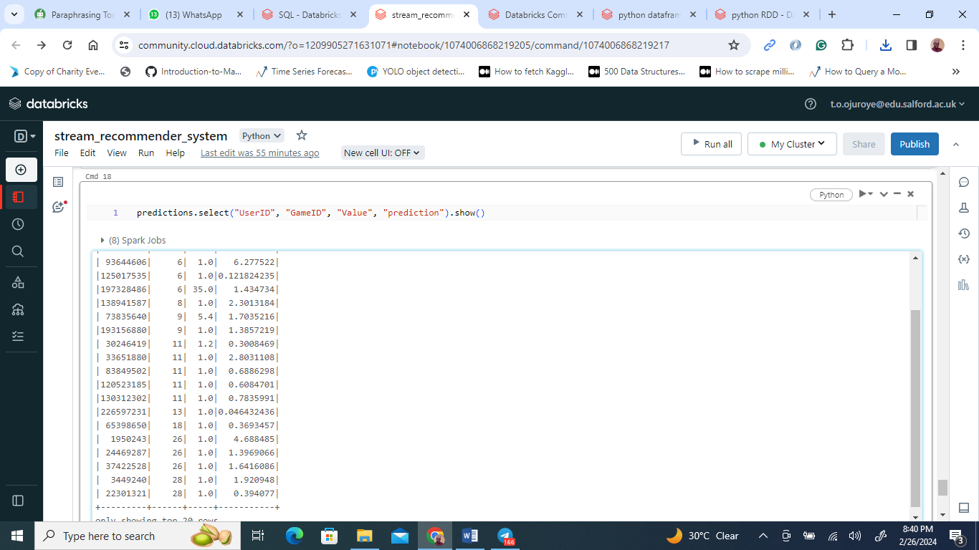

The image depicts the output of a PySpark notebook cell within the Databricks environment, where a trained machine learning model is utilized for generating predictions, likely within a recommender system framework.

The displayed DataFrame, named "predictions," comprises four columns: 'UserID,' 'GameID,' 'Value,' and 'prediction.' Each row corresponds to a user-game pair, with 'UserID' identifying the user, 'GameID' representing the game, 'Value' indicating the actual rating or interaction strength from the user, and 'prediction' denoting the model's estimated rating or interaction for that particular user-game combination.

Utilizing the .show() method, the first 20 rows of the DataFrame are exhibited, showcasing the model's predictions for various user-game pairs. For instance, user 33341552 is predicted to have an interaction value of around 0.6499324 for game 1, while user 139844567 is anticipated to rate game 6 at approximately 2.3729383, and so forth.

Moreover, the image includes a log message pertaining to MLflow, a comprehensive platform for managing the machine learning lifecycle. The log indicates that the model has been logged with MLflow and is being loaded from the Databricks artifacts repository. It also references an issue regarding the inference of pip requirements, although it does not seem to hinder the prediction generation process. Additionally, the log provides insights into the model's performance, including its RMSE (root-mean-square error) and key hyperparameters such as 'rank' and 'regParam,' offering valuable details regarding the model's configuration and effectiveness.